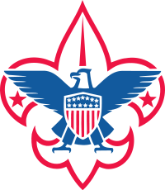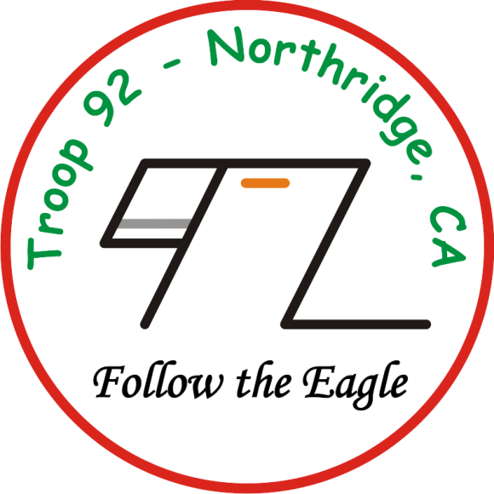
1
Red
Shirt
2
Combat
Wombats
3
Ghost
Squadron

